1.

INCLUDE Irvine32.inc

.DATA

v1 BYTE 1

v2 WORD 2

v3 DWORD 3

v4 DWORD ?

v5 DWORD ?

.CODE

main PROC

movzx eax, v1

mov v4, eax

movzx eax, v2

mov v5, eax

mov eax, v5

mov ebx, v4

mov ecx, v3

call DumpRegs

exit

main ENDP

END main

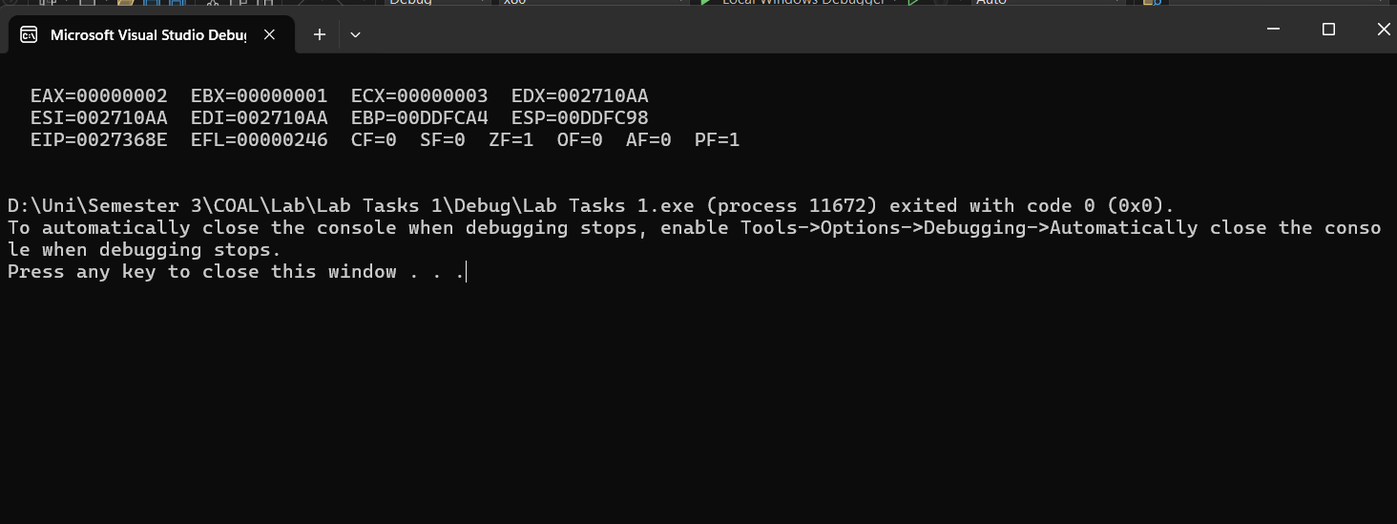

2.

INCLUDE Irvine32.inc

.DATA

v1 BYTE 1

.CODE

main PROC

movzx eax, v1

call writedec

call crlf

call writebin

call crlf

call writehex

call crlf

call DumpRegs

exit

main ENDP

END main

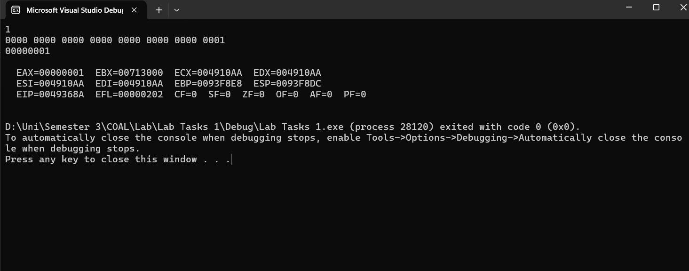

3.

INCLUDE Irvine32.inc

.DATA

num1 dword 24

num2 dword 12

num3 dword 3

val1 dword 4

val2 dword 3

.CODE

main PROC

mov eax, num1

mov edx, 0

div val1

mov eax, edx

div num3

mov ebx, eax

mov eax, num3

mul val2

add num2, eax

mov eax, ebx

mul num2

call writedec

main ENDP

END main

